ASN HDU Home Dialysis Education Virtual Series: Session 3 Cases
Virtual Series Website: Contains links to all Zoom Sessions, recordings, faculty bios, virtual series schedule, home dialysis resource links
https://epc.asn-online.org/projects/home-dialysis-university/
Virtual Series Contacts:
- For website edits, account problems, password resets:
Matt Howard: mhoward@asn-online.org Phone: (202) 640-5602
- For all other inquiries:
Kerry Leigh, kleigh@asn-online.org

Session 3: Home hemodialysis access and cannulation training
Topics:
- Training techniques and strategies for success vascular access cannulation
- Buttonhole cannulation
- Management of dialysis access complications
- Hemodialysis access
- Central line associated bacteremia

Cases:

- A 51-year-old male with type 2 diabetes has been undergoing center-based hemodialysis for 6 months, the first 3 months with a right IJ tunneled catheter and currently a left forearm AVF. He is now preparing to transition to home hemodialysis and will be a self-cannulator.

  - Which type of AVF cannulation should he choose: buttonhole (single site with a blunt needle) or rope-ladder (rotating site with a sharp needle)?
  - What strategies would ensure his successful training?
  - After he successfully transitions to home hemodialysis, what history and exam findings are important for the nurse and physician to review each month at the clinic visit?

- At the first clinic visit, the patient is doing very well, but has noticed itching and discoloration over his access (below). What is your approach to this?
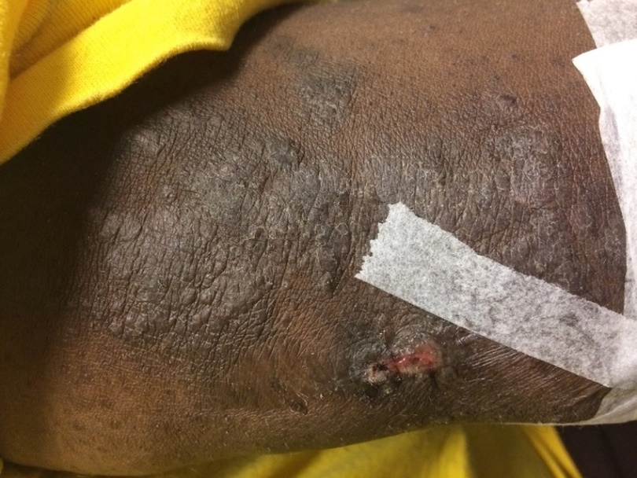

- The same patient was trained in using buttonhole technique, but after 6 months on home hemodialysis, he developed a febrile illness with positive blood cultures for staph aureus. He is now hospitalized and was started on Vancomycin. He has no evidence of PNA, UTI, or any other source for infection. There is no drainage, but there is mild induration of his buttonhole sites.

- What is your approach to this patient going forward?
- What is your approach to the home dialysis program QAPI?

- A 48-year-old woman with IgA Nephropathy has transitioned from PD to HHD. She was able to start HHD with a right upper arm AVF using rotating site cannulation. For the first 6 months the cannulation was without problem. She is now struggling with the cannulation of the distal site, particularly when the needle is advanced after getting a blood return. She has had several infiltrations. On exam, the AVF has a brisk thrill and is larger over the initial six months, but otherwise all exam findings and history are normal.

  - What do you do next?

- In an HHD patient with an AVF, what are the common findings of venous stenosis that require intervention?

- A patient has been doing HHD well with a right IJ tunneled catheter for 9 months and is reluctant to be evaluated for an AVF or AVG. In your discussion with her, what complications would you point out are more common with a catheter than either an AVF or AVG that would outweigh her fear of needles and convenience of a catheter?

