ASN HDU Home Dialysis Education Virtual Series: Session 2 Guide
Virtual Series Website: Contains links to all Zoom Sessions, recordings, faculty bios, virtual series schedule, home dialysis resource links
- If you have already registered for access to the website, login here:
https://epc.asn-online.org/projects/home-dialysis-university/
- If you do not yet have a login, register here:
https://epc.asn-online.org/projects/home-dialysis-university/hdu-member-registration/
Virtual Series Contacts:
- For website edits, account problems, password resets:
Matt Howard: mhoward@asn-online.org Phone: (202) 640-5602
- For all other inquiries:
Kerry Leigh, kleigh@asn-online.org

Session 2: Peritoneal dialysis access creation and maintenance
Topics:
- Pre-operative evaluation and preparation
- Post-operative care and evaluation
- Management of dialysis access complications
- Access infection – evaluation and management
- Is there a role for radiology/nephrology placed PD catheters?
- Quality improvement for PD access – how to communicate with your surgeon.

Session Cases:
Case A:
A 56-year-old woman with CKD due to diabetic nephropathy has been referred for PD catheter placement. Her eGFR is 6 mL/min, she is 5ft 3in tall, and weighs 80kg. She is at your office for a pre-operative routine visit; her surgery will be in 3 days.

  - What relevant parts of the history are crucial in advance of PD catheter (PDC) placement to improve catheter success?

  - What physical exam maneuvers should be performed in preparation for PDC placement?

  - What post-operative instructions does she need?

  - Would you change any of the practice, if an urgent PD is planned?
Case B:
A 64-year-old male with ESKD due to diabetic nephropathy has been on NIPD for 1 year. His prescription is 9 hours cycler treatment time, 4 nocturnal cycles of 2000mL each, and no last fill. His urine output has gone down over the last few months. At his monthly visit, his weight is 5 lb higher than last month and BP now 130s systolic, as compared to 120s before. On review of his dialysis flowsheets, his UF had been lower than his usual for last few weeks and drain time for each cycle was 30-40 minutes. This morning the total cycler UF reported was 200mL. He has no abdominal pain, but his abdomen is slightly distended and soft. You ask the PD RN to do a manual exchange in the clinic now. She calls back reporting that 1 L infuses in 5 minutes and then initial 200 mL drained slowly, but then stopped and no further fluid drained. The patient stood up and changed position a few times, without resumption of drain flow.
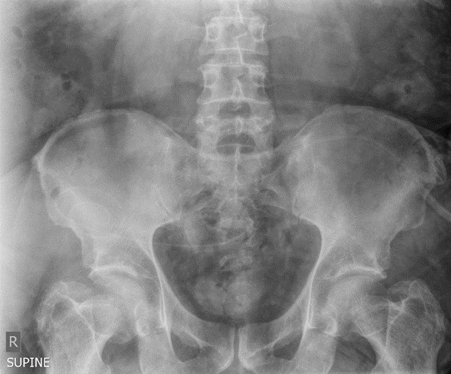
  - What is your next step?

  - Would you instill Tissue plasminogen activator (tPA) into the catheter lumen.

  - A KUB is obtained, what does this show?

  - What is the next step?

Case C:
37 yo female with ESKD due to IgA nephropathy on PD for 2 years. She has done well in general but one peritonitis episode in the 5 years (treated as outpatient successfully).
She comes in for her monthly visit and has a complaint of pain and redness around the PD catheter. PD exit site examination reveals the following: When the PD nurse examines the catheter, she finds that the dressing is little wet and purulent, there is redness around the PD catheter exit site, with mild tenderness to palpation.

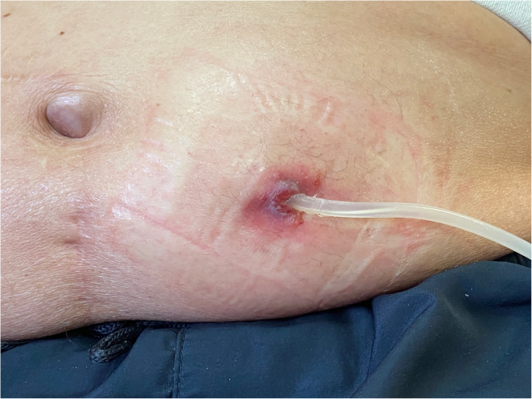
- Is this a PDC exit site infection (PDC ESI)? How do you diagnose PDC ESI? What are the criteria?

- What treatment is needed now?

- Do you need to remove the catheter?

Case D:
47-year-old male with ESKD due to polycystic kidney disease, recently completed PD training and started at home on NIPD. On day 3, he calls reporting sharp pain on first fill lasting about a minute, and also during each drain cycle. He was asked to ensure taking laxatives and having regular soft bowel movements. He called on day 6 that his fill pain has resolved and drain pain has improved but not resolved and it has been discomforting.

- What causes fill or infusion and drain pain?

- How do laxatives help with fill or drain pain?

- What can be done next to help this patient?

