Cases
1.Bernie is 54 y/o male with PMH of Type II DM and HTN who was incenter for hemodialysis​He switched to home hemodialysis as he wishes to travel​. He is currently training on a tunneled hemodialysis catheter. Left Brachiocephalic fistula for past 1 year​. Infiltration on each attempt​. According to the surgeon, "perfect access"​. The fistula has good bruit and thrill. The nurses attempt to cannulate at your clinic, but it gets infiltrated.
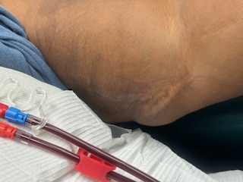
What would be your next step?
- Order Doppler’s of vascular access
- Order a fistulogram
- Discuss with vascular surgeon
- Refer for new vascular access to a different surgeon
- Both A and C

2.Jack is 62 y/o male with HFrEF, Type II DM with macrovascular complications. He is on 5 days /week Short daily home hemodialysis, his prescriptions is BFR 400, Fluid 30L, FF 30%. He struggles with intradialytic hypotension due to HFrEF. He has left brachiocephalic access. He recently has a coated stent placed. You see him at the clinic for monthly visits. The picture of the access is below.
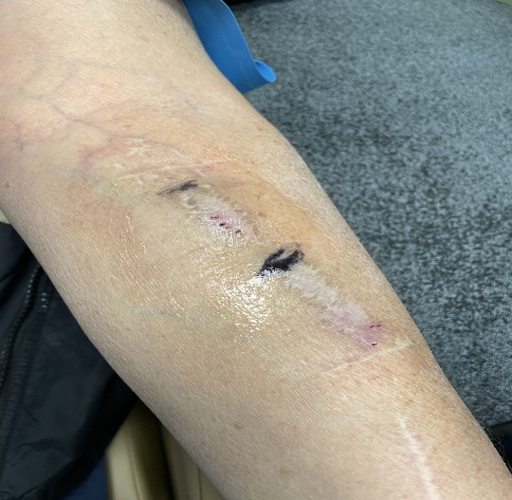

- What are you concerned about
- How would you counsel the patient and wife

3.Jamie is 22 y/o female on home hemodialysis. She failed her transplant at age of 19. She was initially on PD and developed peritonitis. She switched to SDHD. Her mother is her partner, and her friend is getting worked as a donor. She is currently dialyzing on tunneled dialysis catheter. She absolutely does not want an arteriovenous fistula/graft.
What should you do next?
- Discharge from your practice
- Discuss with her risk and benefit of Tunneled CVC.
- Refer to a different HHD clinic as it CVC numbers are impacting your QIP
- Tell her she is not a good home hemodialysis candidate and needs to transfer to HHD
What is the risk with CVC’s
- Higher risk of infection than AVF
- Higher risk of mortality as compared to AVF
- There are no sterile techniques to decrease the risk of infections
- Increased risk of central venous stenosis
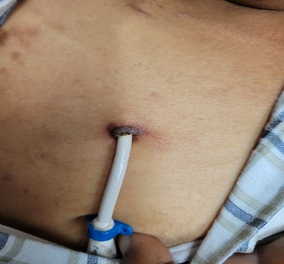
4.Jamie comes to the clinic with fevers and chills. The picture of her CVC insertion site is below. What should we do next?
- Send her to hospital
- Culture the exit site and start on PO Augmentin
- Collect blood cultures and get Tunneled CVC exchanged
- Start on IV Antibiotics and exchange TDC.

5. What are techniques that have demonstrated reduced the risk of infections with CVC
- Scrub the hub
- Wearing the mask while connecting and disconnecting
- Hand hygiene
- Heparin lock solution
- Toluridine lock solution

